NCR 56XX ATM Device Status

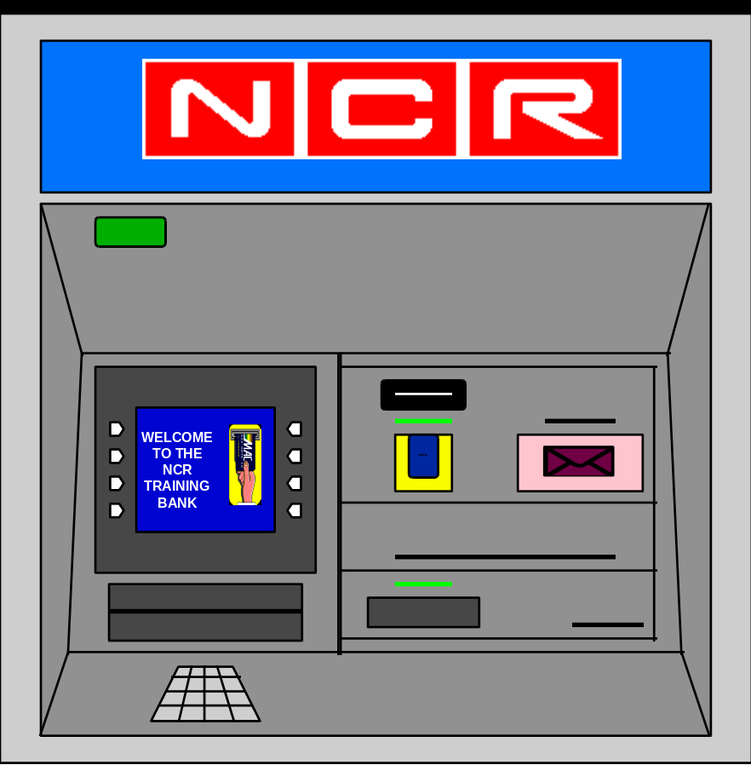

This guide is effective for NCR ATM models 5674, 5675, 5684, 5685 and 5688
running NDC+ Direct Connect software up to and including release 2.01.01

The information contained in this manual is NCR/AT&T Intellectual Property
Table of Contents

Device Status Value Definitions
Device Code A = Time of Day Clock
Device Code B = Power Failure
Device Code D = Card Reader / Writer
Device Code E = Currency Dispenser
Device Code F = Depository
Device Code G = Receipt Printer
Device Code H = Journal Printer
Device Code L = Encryptor
Device Code P = Sensors
Command Rejects

Three attachments are included at the back of this publication. These attachments are taken directly from NCR 56XX ATM Operations Manuals and the Currency Cassette Manual. The information in these sections detail the Replenishment Procedures for all devices on both front and rear access 56XX ATMs.

Device Status Value Definitions

The following pages provide a detailed description of the individual status messages that are produced for the various devices in the ATM. (Only the status messages that pertain to the 56XX model ATMs as equipped for Mellon Bank are referenced.) Refer to the guide on the previous page for the definition of the fields that comprise the individual status codes. The fields within each device are color coded in accordance with the format described on the reference guide.

Please note that many of the error conditions will not display during normal operation. These error conditions will only be produced as a result of diagnostic testing.

Device Code A = Time of Day Clock

Format = *tttt*m*A*a

Field Specifics ⇒ *tttt*m*A*a

a = Device Status

Possible Values for "a":
1 = Clock reset but running
2 = Clock Stopped

Example: *1234*1*A*2

Interpretation: During transaction number "1234", the ATM generated its own unsolicited status
message (1) from the Time of Day Clock (A) indicating that the clock has stopped (2).

Device Code B = Power Failure

Format = *tttt*m*B*aaaa

Field Specifics ⇒ *tttt*m*B*aaaa

aaaa = Configuration ID
(Network Services assigned terminal group number)

Example: *1234*1*B*0011

Interpretation: After transaction number "1234", the ATM generated its own unsolicited status message (1) after encountering a Power Failure (B). The message also indicates that the ATM was loaded with terminal group "0011" as assigned by Network Services.

Device Code D = Card Reader / Writer

Format = *tttt*m*D*a, M-bb, R-c

Field Specifics ⇒ *tttt*m*D*a, M-bb, R-c

a = Transaction / Device Status

Possible Values for "a":

0 - Minor problem, refer to "bb" and "c" data status and supply changes
1 - Cardholder did not take his card within the allotted time and it was captured or jammed
2 - Eject failure, card captured or jammed
3 - Failed to write on Track 3 of the card
4 - Invalid Track 3 data sent from network

Field Specifics ⇒ *tttt*m*D*a, M-bb, R-c

bb = Module Status

Possible Values for "bb":

00 - Operation successful
01 - Blank track
02 - Track not supported
03 - Read error
04 - Write error
05 - No card in reader at start of command
06 - Card removed by customer during capture
07 - Shutter jammed open
08 - Shutter switch failure detected
09 - Error recovery successful
10 - Shutter jammed closed
11 - Card jammed (not during capture)
12 - Card captured after unsuccessful eject operation
13 - Possible customer tampering, card stuck in card reader throat
14 - Too many consecutive read errors or blank tracks
15 - Too many consecutive write errors
16 - Too many consecutive card jams
17 - Too many consecutive shutter jammed closed status's
18 - Card jam during capture
19 - Too many consecutive invalid cards
20 - Device still inoperable
21 - No card entered during cleaning cycle test
22 - Speed out of specification > +3%
23 - Speed within +3%
24 - Speed within +/- 1%
25 - Speed within -3%
26 - Speed out of specification < -3%
27 - Invalid card detected (diagnostic only)
37 - Card Return on Power Failure option not supported
38 - Tamper Indicating Card Capture bin full
39 - Tamper Indicating Card Capture bin shutter mechanism failure
40 - Tamper Indicating Card Capture bin removed or not configured
41 - Card Return on Power Failure option failed
146 - SDC link failure
Field Specifics ⇒ *tttt*m*D*a, M-bb, R-c

c = Supply Status

Possible Values for "c":

0 - No new state
1 - Card capture bin is not overfilled
4 - Card capture bin is overfilled

Example: *1234*2*D*2, M-11, R-1

Interpretation: During transaction number "1234", the ATM generated a solicited status message (2) resulting from the network telling the ATM to return the card to the customer. The card reader (D) failed in its attempt to eject the card (2) and the card became jammed in the card reader (M-11). In addition to this information, the status indicated that the card capture bin is not overfilled (R-1).

Device Code E = Currency Dispenser

Format = *tttt*m*E*aaaaaaaaa, M-bb, R-ccccc

Field Specifics ⇒ *tttt*m*E*aaaaaaaaa, M-bb, R-ccccc

aaaaaaaaa = Transaction / Device Status
(This field describes what happened during the transaction using the first digit of the field and how many bills were dispensed from each currency cassette using the remaining 8 digits of the field.)

Possible values for each digit of "a aa aa aa aa":

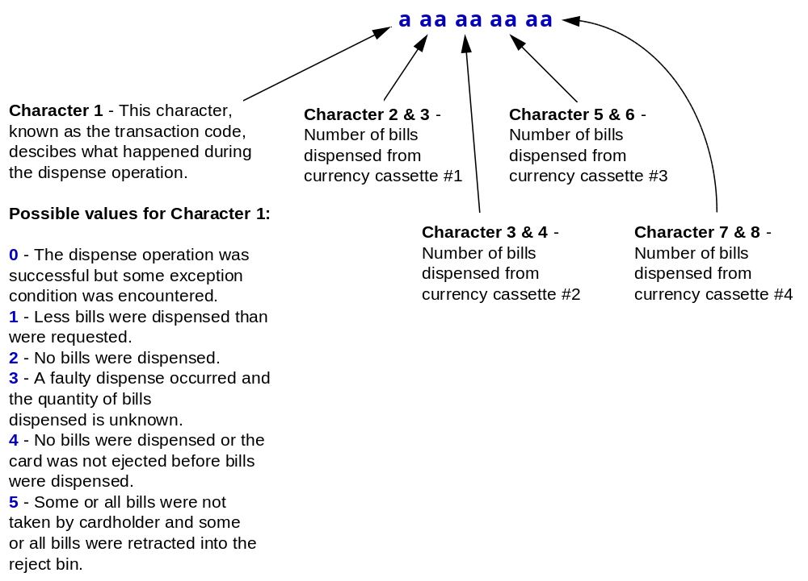

Field Specifics ⇒ *tttt*m*E*aaaaaaaaa, M-bb, R-ccccc

bb = Module Status

Possible values for "bb":

00 - No error
01 - Pick requested from cassette that is not installed
02 - Too many bills being rejected
03 - Pick failure
04 - Pick failure from cassette low or out of currency
05 - Sensor failure or currency jammed
06 - Divert gate failure
07 - Reject bin not present
08 - Reject bin overfilled or sensor blocked
09 - Communications failure at dispenser
10 - Operation not attempted due to previous failure
11 - Bills still in transport, operation not attempted
12 - Presenter mechanism failed or jammed
13 - Exit shutter jammed open
14 - Exit shutter jammed closed
15 - Bills observed passing overfill sensor
16 - Main transport timing disk or main AC motor failed
17 - Exit sensor failed to clear or is blocked
18 - Currency jam in presenter transport or sensor failed
19 - Exit sensor blocked (bills may be in exit slot)
20 - Dispenser not configured
21 - Security violation
22 - Security inhibition
25 - Flex disk authorization not required
28 - An area of NVRAM cannot be accessed (SOH cannot be updated)
29 - Presenter transport timing disk or motor failure
30 - Presenter transport sensors blocked or failed
32 - Heartbeat on execution processor failed (80652)
33 - Communication failure on the I2C bus (80852)
34 - A present notes operation has been attempted without any notes being stacked or a retract operation has been attempted without notes having been presented
35 - Operation incomplete due to power disconnection resulting from the interlock on the ATM access door being tripped
36 - Pick valve test not attempted because cassettes were installed
37 - Tamper Indicating service switched ON
38 - Tamper Indicating service switched OFF
39 - LVDT or associated circuitry malfunctioning
40 - Note parameters not configured because of an NVRAM corruption or it is the first operation since initial power-up
41 - An attempt was made to pick from a cassette which has been disabled for in-service replenishment
146- SDC link failure

Field Specifics ⇒ *tttt*m*E*aaaaaaaaa, M-bb, R-ccccc

ccccc = Supply Status
(This 5-digit supply field describes the state of the currency reject bin and each of the currency cassettes.)

Description and possible values for "ccccc":
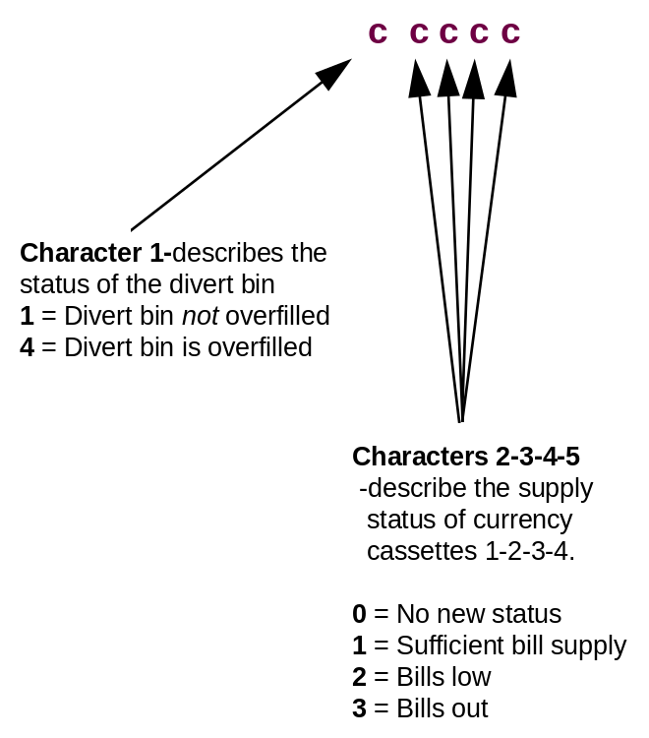

Example: *1234*2*E*101010000,M-04,R-13100
(In this example, the customer requested $50 but only received $30)

Interpretation: As a result of transaction 1234 where the host directed the ATM (2) to dispense currency (in this case 2 - $20 bills and 1 - $10 bill), the currency dispenser (E) encountered a pick failure while attempting to get bills from a cassette that was low on currency (M-04). The transaction status (101010000) indicates that less bills were dispensed than were requested (digit 1 = 1), one bill was dispensed from currency cassette 1 (digits 2&3 = 01) and one bill from currency cassette 2 (digits 3 & 4 = 01). The supply status (R-13100)determines that the reject bin is not full (digit 1 = 1), currency cassette 1 is out of bills (digit 2 = 3) and currency cassette 2 has a sufficient bill supply (digit 3 = 1).

Device Code F = Depository

Format = *tttt*m*F*a, M-bb, R-c

Field Specifics ⇒ *tttt*m*F*a, M-bb, R-c

a = Transaction / Device Status

Possible values for "a":

0 - Successful operation, but an exception condition was encountered
1 - Customer did not insert the envelope in the allotted time
2 - Failure to enable mechanism for a deposit
3 - Deposit failed, customer has access to the envelope
4 - Deposit failed, envelope is in the ATM and the customer does not have access to it

Field Specifics ⇒ *tttt*m*F*a, M-bb, R-c

bb = Module Status

Possible values for "bb":

0 - No error
1 - Transport jam
2 - Transport jammed and shutter jammed open
3 - Transport jammed and shutter jammed closed
4 - Shutter jammed open
5 - Shutter jammed closed
6 - Transport sensor failed
7 - Depository communication failure
11- Depository bin overfill
13 - Timing disk failure
14 - A failure has occurred in the control electronics
15 - Transport motor failure
50 - Anti fishing sensor not returned
51 - Lost depository print characters due to transport speed (incomplete envelope printing)
52 - Printhead removed
55 - Interlock failed
146 - SDC link failure

Field Specifics ⇒ *tttt*m*F*a, M-bb, R-c

c = Supply Status

Possible values for "c":

0 - No envelope deposited
1 - The depository bin is not overfilled
4 - The depository bin is experiencing an overfill condition

Example: *1234*2*F*4, M-01, R-1

Interpretation: In transaction (1234), the host directed the ATM (2)to accept a deposit (F), but the deposit failed and the customer does not have access to the envelope (4) due to a transport jam (M-01). The supply status indicates that the depository bin is not overfilled (R-1).

Device Code G = Receipt Printer

Format = *tttt*m*G*a, M-bb, R-cccc

Field Specifics ⇒ *tttt*m*G*a, M-bb, R-cccc

a = Transaction / Device Status

Possible values for "a":

0 - Successful print
1 - Print not successfully completed
2 - Device not configured

Field Specifics ⇒ *tttt*m*G*a, M-bb, R-cccc

bb = Module Status

Possible values for "bb":

00 - No error
01 - Head jam/Knife jam
03 - Black mark error
05 - Paper out
07 - Paper not loaded or paper jam before transport
08 - Communications failure to the printer
09 - Printer open
10 - Ribbon needs to be replaced soon
11 - Printhead needs to be replaced soon
12 - Knife needs to be replaced soon
13 - Ribbon needs to be replaced now
14 - Printhead needs to be replaced now
15 - Sideways communications error
16 - Eject jam
146- SDC link failure

Field Specifics ⇒ *tttt*m*G*a, M-bb, R-cccc

cccc = Supply Status
(This 4-digit field contains multiple values for each character)

Description and possible values for "cccc":
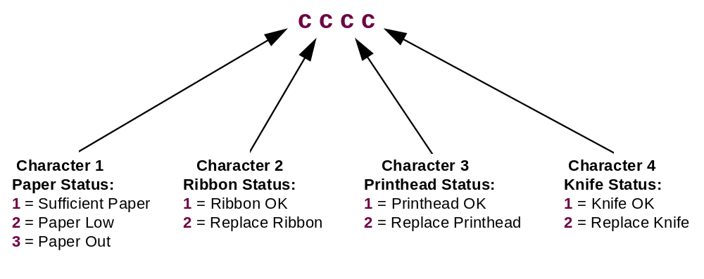
Example: *1234*1*G*1, M-05, R-3111

Interpretation: In transaction (1234), the ATM attempted (1) to print a customer receipt on the receipt printer (G) but was unsuccessful in its attempt (1) as the printer was out of paper (M-05). The supply status (R-3111) echoed the fact that paper was out (digit 1) and also that the ribbon (digit 2), printhead (digit 3) and the paper cutting knife (digit 4) were all OK.

Device Code H = Journal Printer

Format = *tttt*m*H*a, M-bb, R-ccc

Field Specifics ⇒ *tttt*m*H*a, M-bb, R-ccc

a = Transaction / Device Status

Possible values for "a":

0 - Successful print
1 - Print not successfully completed
2 - Device not configured

Field Specifics ⇒ *tttt*m*G*a, M-bb, R-ccc

bb = Module Status

Possible values for "bb":

00 - No error
01 - Head jam
05 - Paper out
07 - Paper not loaded
08 - Communications failure to the printer
09 - Printer open
10 - Ribbon needs to be replaced soon
11 - Printhead needs to be replaced soon
13 - Ribbon needs to be replaced now
14 - Printhead needs to be replaced now
146- SDC link failure

Field Specifics ⇒ *tttt*m*G*a, M-bb, R-ccc

ccc = Supply Status
(This 3-digit field contains multiple values for each character)

Description and possible values for "ccc":

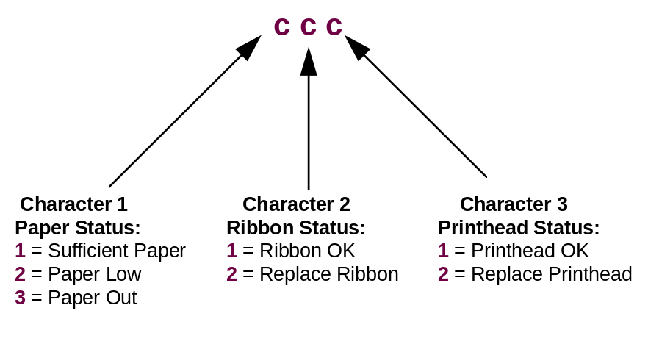

Example: *1234*1*H*1, M-05, R-311

Interpretation: In transaction (1234), the ATM attempted (1) to print information on the journal printer (H) but was unsuccessful in its attempt (1) as the printer was out of paper (M-05). The supply status (R-311) echoed the fact that paper was out (digit 1) and also that both the ribbon (digit 2) and the printhead (digit 3) were both OK.

Device Code L = Encryptor

Format = *tttt*m*L*a, M-bb

Field Specifics ⇒ *tttt*m*L*a, M-bb

a = Transaction / Device Status

Possible values for "a":

1 - Encryptor error
2 - Encryptor not configured

bb = Module Status

Possible values for "bb":

00 - No error detected
01 - Parity error
02 - Hardware error
03 - Invalid command, not all key spaces are closed
04 - Invalid command, no key space open
05 - Invalid command as keyboard is currently enabled
07 - Communications failure
08 - Security module reset was successful
11 - Invalid command data
12 - Data mismatch
13 - No key loaded in Data Encryption Unit prior to encryption or decryption request
12 - Data mismatch
70 - PIN verification failed
74 - Invalid PIN encrypt type function (encryption mode changed)
75 - Key integrity error
76 - Invalid PIN, no encryption allowed (truncated PIN does not contain decimal digits)
97 - Timeout error
98 - Communications error
146 - SDC link failure

**Note - several additional Module Status error values exist in the range 15 - 66 that apply to programmer level individuals and would be recorded on the network BLF listing**

Example: *1234*1*L*1, M-04

Interpretation: In transaction (1234), the ATM attempted (1) to encrypt (L) data (the customer PIN) but an encryptor error occurred (1) as a result of the DES key not being installed (M-04). This would generally require a technician to come to the machine to re-enter the DES keys.

Device Code P = Sensors

Format = *tttt*m*P*aaaaaaaaaaaaa

Field Specifics ⇒ *tttt*m*L*aaaaaaaaaaaaa

aaaaaaaaaaaaa = Device Status
(There are distinct values for each of the 13 characters represented in the Device Status codes referencing Sensors. The following descriptions and values define each character beginning with the first, character 1.)

Description and possible values for each character of "aaaaaaaaaaaaa":

Character 1
1 - Tamper Indicating sensor change *
2 - Mode switch change (the Mode Switch is the Normal/Supervisor switch on the operator panel) **
3 - Alarm state change *

Character 2
0 - Mode switch moved to NORMAL
1 - Mode switch moved to SUPERVISOR
Character 3
0 - Vibration and/or heat sensor inactive
1 - Vibration and/or heat sensor active
Character 4
0 - Door contact sensor inactive
1 - Door contact sensor active
Character 5
0 - Silent signal sensor inactive
1 - Silent signal sensor active
Character 6
0 - Electronics enclosure sensor inactive
1 - Electronics enclosure sensor active
Character 7
0 - Deposit bin in
1 - Deposit bin out
Character 8
0 - Card capture bin out
1 - Card capture bin in
Character 9
0 - Currency reject bin out
1 - Currency reject bin in

* If Character 1 = "1" (Tamper Indicating sensor change) or "3" (Alarm state change), then Character 2 is not applicable and Characters 3 thru 13 provide details describing the Tamper Indicating or Alarm status.
** If Character 1 = "2" (Mode switch change), then Character 2 provides the details concerning the mode switch and Characters 3 thru 13 will be omitted.

Character 10
0 - Currency cassette in position 1 out (top)
1 - Currency cassette in position 1 in
Character 11
0 - Currency cassette in position 2 out (second)
1 - Currency cassette in position 2 in
Character 12
0 - Currency cassette in position 3 out (third)
1 - Currency cassette in position 3 in
Character 13
0 - Currency cassette in position 4 out (bottom)
1 - Currency cassette in position 4 in

Please note that many of these Sensor Status changes are also logged on the journal tape in plain English.

Example: *1234*1*P*20

Interpretation: Following transaction (1234), the ATM (1), as a result of user intervention, underwent a change in the position of the mode switch (20). Character 1 of the module status (20) indicated the mode switch change while Character 2 of the module status (20) indicated that the mode switch was switched to the Normal position. In this example, the text "SUPERVISOR MODE EXIT" would also have printed on the journal tape.

Command Rejects
These error messages print on the journal tape in response to a message that was sent by the network to the ATM in some form that was not acceptable by the ATM. It can generally be assumed that the transaction attempted did not successfully complete. Further information as to the cause and resolution of this problem will require investigation by you Network Services Customer Service Representative.

Format = *tttt*2*CNN

Field Specifics ⇒ *tttt*2*CNN

C = Specific Command Reject Category

Possible Values for "C":

1 - Message Authentication Code
2 - Time Variant Number Failure
3 - Security Terminal Number Mismatch
A - Message Format Error
B - Field Value Error
C - Illegal Message Type for Current Mode
D - Hardware Failure
E - Not Supported

Values for NN carry different meanings depending on the value for C. The following sections describe the different meanings for NN under the various values for C.
4If the value for C = "A" (message format error), then the possible values and descriptions for NN are:

01 - Message length error (
02 - Field separator missing or unexpectedly found
03 - Transaction reply message has too many print groups

4If the value for C = "B" (field value error), then the possible values and descriptions for NN are:

01 - Illegal message class (outside range of 1 -4)
02 - Illegal message subclass or identifier on a configuration load message with class 3
03 - Illegal load key message identifier
04 - Illegal terminal command code
05 - Illegal terminal command modifier
06 - Illegal function ID in transaction reply command
07 - Data field contains non-numeric data
08 - Numeric value out of range (Fit value greater than 255)
09 - Invalid message coordination number
10 - Illegal FIT number (not in range 000 - 254)
11 - Too many bills in transaction reply command (total exceeds 40 bill maximum)

4If the value for C = "C" (illegal message type for current mode), then the possible values and descriptions for NN are:

01 - Message type only accepted while ATM is in "in-service" mode
02 - Message can not be accepted while diagnostics are in progress
03 - Message can not be accepted while in "out-of-service or supply" mode
04 - Message can not be accepted while in "in-service" mode
05 - Message not allowed while terminal configured for NCR status mode
06 - Message not allowed while terminal configured for Diebold status mode

4If the value for C = "D" (hardware failure), then the possible values and descriptions for NN are:

01 - Encryption failure during key change message
02 - Time of day clock failure during date/time set command or invalid data sent

4If the value for C = "E" (not supported), then the possible values and descriptions for NN are:

01 - Command not supported by software version currently in use
02 - Device required to accommodate the command is not configured

Example: *1234*2*D01

Interpretation: After transaction 1234, the ATM network (2) attempted to send a new encryption key (used to conceal a customer's PIN when sent for authorization) to the ATM but a hardware error was detected (D) that indicated that an encryption failure occurred during the key change message (01).

